2016

Ryan Archibald, FIT

Kirsten Kurjata, A. Ag.

Lindsay Dent, FIT

Andrew Spence, FF, EMT-P

Mike Poscente, RPFT, MBA

**CPP Environmental**

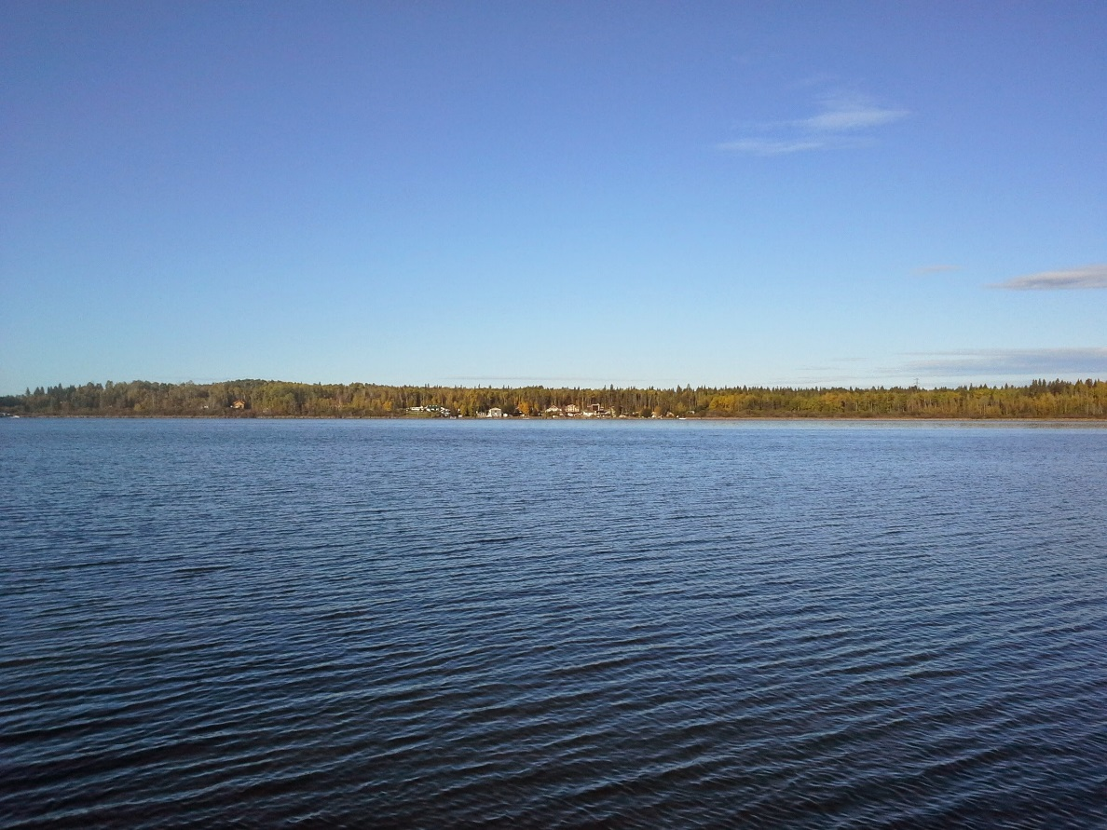

Fire Protection Plan: Workbook

**Acknowledgements**

The Fire Protection Plan was made possible by a grant received from Alberta Municipal Affairs. The Summer Village of Norglenwold applied for the grant to develop products so that all Summer Villages can develop unique plans based on the conditions within their communities. The Summer Village of Norglenwold administered funds on behalf of project participants and acquired the appropriate contractors to complete the tasks. The Association of Summer Villages of Alberta (ASVA) assisted with project management and review of draft and final products.

The Fire Protection Plan was developed with the guidance of the ASVA and feedback from the Board of Directors.

The Board of Directors include:

* Peter Pellatt, President
* Bob Yontz, Vice President
* Leslie Ellis, Past President
* Rob Dickie, Treasurer
* Beverly Anderson, Executive Director
* Gary Burns, Director
* Chuck Dechene, Director
* Dennis Evans, Director
* Betty Forfylow, Director
* Pete Langelle, Director
* Joyce Megson, Director
* Glen Usselman, Director
* Marlene Walsh, Director

A special thanks to the following fire professionals whom added input to the Fire Protection Plan

* Integrated Emergency & Safety Services Inc.

|  |  |  |  |
| --- | --- | --- | --- |
|  |  | |  |
|  |  | |  |
| C:\Users\Preferred Client\AppData\Local\Microsoft\Windows\Temporary Internet Files\Content.Outlook\E6IGO8YL\image001.jpg | |  | |

Table of Contents

Fire Protection Planning Process 1

Fire Protection Plan: Workbook 2

Step 1 Planning 3

1.1 Stakeholder Involvement 3

1.2 Community Characteristics and Values 4

1.3 Review Current Programs 5

1.4 Review Existing Plans 5

1.5 Accreditation Audit Form 5

Step 2 Goals and Objectives 6

2.1 Goal Development 6

2.2 Defining Objectives 6

Step 3 Accreditation Audit Form Analysis 7

3.1 Fire Department Resources and Emergency Response 7

3.2 Water Resources 8

3.3 Evacuation 9

3.4 Wildfire 10

3.5 Outside Fuel and Ignition Hazards – Private 11

3.6 Outside Fuel and Ignition Hazards – Public 12

3.7 Structures – Residential 13

3.8 Structures – Community 14

3.9 Community Access 15

3.10 Industrial Activities 16

3.11 Utilities 17

3.12 Other Risks 18

Step 4 Action and Implementation 19

4.1 Developing Actions 19

4.2 Implementing Actions 20

Step 5 Monitoring and Evaluation 22

5.1 Monitoring 22

5.2 Evaluation 23

Summary of Fire Protection Process 24

# Fire Protection Planning Process

The purpose of a Fire Protection Plan is to provide an administrative process to document adaptive management by the Summer Village to minimize losses due to fire. A Fire Protection Plan must be completed with the aid and support of fire professionals and industry leaders. Three documents have been developed for Summer Villages to assist with the completion of their own Fire Protection Plan. The three documents include: The *Fire Protection Plan: Accreditation*; *Fire Protection Plan: Workbook*; and *Fire Protection Plan: Framework*. When utilized together, the three documents will guide a Summer Village through a step-by-step process to develop their own, unique Fire Protection Plan.

The *Fire Protection Plan: Accreditation* is a means for a Summer Village to determine if it is adhering to standards set by the ASVA. The Accreditation Audit Form is the functional portion of the Accreditation document. When completed, the Audit Form will identify strengths and weaknesses for a Summer Village to consider when developing a Fire Protection Plan.

The *Fire Protection Plan: Workbook* provides a step-by-step process to assist summer villages with the development of a Fire Protection Plan. A completed, edited, reviewed workbook will become the Summer Villages Fire Protection Plan. It is recommended that when beginning the Fire Protection Planning Process, it to **follow the step by step process described in the *Fire Protection Plan: Workbook.***

The *Fire Protection Plan: Framework* is a reference document to assist the planning process. The Framework provides additional information and reference material for each section of the Workbook.

By using the three Fire Protection Planning Process documents and additional materials provided by the ASVA, a Summer Village will be prepared to write a Fire Protection Plan for their community. A Fire Protection Plan will illustrate a community’s progressive commitment to public safety.

**Framework**

**Accreditation**

**Workbook**

**Fire Protection Plan**

# Fire Protection Plan: Workbook

The *Fire Protection Plan: Workbook* is intended for a Summer Village to complete with the support of a variety of stakeholders to increase public safety within the community. A completed, edited, reviewed workbook will become a Summer Village’s Fire Protection Plan. The steps to complete a Workbook are illustrated in Figure1. Following the steps in this document will help guide a Summer Village through the planning process.

Figure 1. Fire Protection Planning Process

*Note:* ***This is not a legal document****, it is intended as a guide in developing a Fire Protection Plan. Not all elements of this plan will apply to each Summer Village, and elements may need to be adjusted as necessary based on the needs of the Summer Village.*

# Planning

Step 1 Planning, is important for the development of a Fire Protection Plan. The Summer Village must have a clear understanding of who to involve in the planning process, community characteristics and values, programs that may complement fire protection and any previous planning efforts.

## Stakeholder Involvement

The Summer Village is the primary author of a Fire Protection Plan. However, while developing a Fire Protection Plan, multiple stakeholders should be consulted to assist with the variety of topics covered within a Fire Protection Plan.

**Potential stakeholders:**

*Check if stakeholder will aid with the development of the Fire Protection Plan.*

Summer Village Council

Fire Service Provider

Utilities provider(s):

* + ­­­­­­­

Community members (i.e. community elder)

Other Stakeholders:

## Community Characteristics and Values

Prior to the development of Fire Protection Plan, the Summer Village should analyze their community’s characteristics and values to gain an understanding of the people, surroundings, and resources found in the community. Several aspects to consider are:

*Check boxes when questions and follow up questions have been completed.*

The number of people affected by fire:

* + How many of these people are permanent or seasonal residents?

# Permanent: # Seasonal:

* Are there people with mobility issues?

Types of properties affected by fire in the community?

*Check if these types are present and could be affected by fire in the community.*

Commercial

Public

Recreational

Agricultural

Other:

Types of structures affected by fire?

*Check the types of structures that could be affected by fire in the community.*

Residential

Commercial Building

Community Facility

Other:

Special areas affected by fire?

*Check the types of special areas that could be affected by fire in the community.*

Natural Areas

Environmentally Sensitive Areas

Other:

Have fires affected the Summer Village?

If Yes:

* + How many:
  + How was it started:
  + Were there homes affected:
    - How many:
  + Were there any injuries:
  + Other comments:

Other community considerations:

*List other community considerations that are not covered by the questions above.*

## Review Current Programs

Current programs may already exist in the Summer Village. It is important to review programs for two reasons: first, the types of programs available are indicators to the type of characteristics and values the community have; and second, some of the programs may be relevant to fire protection.

Possible programs the Summer Village has relevant to fire protection:

*Check the current programs in the community that maybe relevant to fire protection.*

Educational speakers

Chimney inspection

Fire extinguisher service and inspection

Maintenance of right-of-ways

Maintenance of vacant lots

Community clean-up day or hazard removal day

Hazard tree removal

Other:

## Review Existing Plans

It is important to search for, and review, any existing fire or emergency plans. Recent plans may have information to assist with filling out this plan. Past plans will give insight into how the community has changed over time. While reviewing existing plans the Summer Village may consider interviewing a Village elder. Their unwritten knowledge of the Village may give an excellent background or history of fire within the village.

Possible existing plans:

*Check the plans that the Summer Village owns.*

Regional Emergency Response Plan

Mutual aid agreements

Community Fire Protection Plan

Wildfire Mitigation Strategy

Others:

## Accreditation Audit Form

*Check when Accreditation Audit Form is complete.*

Accreditation Audit Form Completed

# Goals and Objectives

Based on the knowledge collected through Step 1, the Summer Village can develop goals and objectives for the Fire Protection Plan.

## Goal Development

A goal is an overarching qualitative principle that guides decision making. An example of a goal for the fire protection plan is:

***Minimize losses due to fire.***

## Defining Objectives

Objectives are specific measurable outcomes that, when achieved in combination, provide confidence that the Summer Village is achieving its goals.

The objective of a Fire Protection plan is **to continually increase your Accreditation Audit Form score**.

Notes:

# Accreditation Audit Form Analysis

In this section community attributes identified in the Accreditation Audit Form can be analyzed while considering the goals and objectives developed in Step 2. It is very important to use the knowledge of stakeholders in this section. Stakeholders will help with the identification of hazards. While completing this section continue to ask:

***“What actions will improve the Summer Village’s accreditation score?”***

## Fire Department Resources and Emergency Response

**Answer the Questions**:

Are all standard practices met? Y / N

* + If no, what are the reasons for not meeting standard practices?

Are there feasible opportunities to meet best or leading edge practices? Y / N

* + If yes, which practices are they?

What are other possible best and leading edge practices not listed in the accreditation audit form that may be feasible to implement in the future?

## Water Resources

**Answer the Questions**:

Are all standard practices met? Y / N

* + If no, what are the reasons for not meeting standard practices?

Are there feasible opportunities to meet best or leading edge practices? Y / N

* + If yes, which practices are they?

What are other possible best and leading edge practices not listed in the accreditation audit form that may be feasible to implement in the future?

## Evacuation

**Answer the Questions**:

Are all standard practices met? Y / N

* + If no, what are the reasons for not meeting standard practices?

Are there feasible opportunities to meet best or leading edge practices? Y / N

* + If yes, which practices are they?

What are other possible best and leading edge practices not listed in the accreditation audit form that may be feasible to implement in the future?

## Wildfire

**Answer the Questions**:

Are all standard practices met? Y / N

* + If no, what are the reasons for not meeting standard practices?

Are there feasible opportunities to meet best or leading edge practices? Y / N

* + If yes, which practices are they?

What are other possible best and leading edge practices not listed in the accreditation audit form that may be feasible to implement in the future?

## Outside Fuel and Ignition Hazards – Private

**Answer the Questions**:

Are all standard practices met? Y / N

* + If no, what are the reasons for not meeting standard practices?

Are there feasible opportunities to meet best or leading edge practices? Y / N

* + If yes, which practices are they?

What are other possible best and leading edge practices not listed in the accreditation audit form that may be feasible to implement in the future?

## Outside Fuel and Ignition Hazards – Public

**Answer the Questions**:

Are all standard practices met? Y / N

* + If no, what are the reasons for not meeting standard practices?

Are there feasible opportunities to meet best or leading edge practices? Y / N

* + If yes, which practices are they?

What are other possible best and leading edge practices not listed in the accreditation audit form that may be feasible to implement in the future?

## Structures – Residential

**Answer the Questions**:

Are all standard practices met? Y / N

* + If no, what are the reasons for not meeting standard practices?

Are there feasible opportunities to meet best or leading edge practices? Y / N

* + If yes, which practices are they?

What are other possible best and leading edge practices not listed in the accreditation audit form that may be feasible to implement in the future?

## Structures – Community

**Answer the Questions**:

Are all standard practices met? Y / N

* + If no, what are the reasons for not meeting standard practices?

Are there feasible opportunities to meet best or leading edge practices? Y / N

* + If yes, which practices are they?

What are other possible best and leading edge practices not listed in the accreditation audit form that may be feasible to implement in the future?

## Community Access

**Answer the Questions**:

Are all standard practices met? Y / N

* + If no, what are the reasons for not meeting standard practices?

Are there feasible opportunities to meet best or leading edge practices? Y / N

* + If yes, which practices are they?

What are other possible best and leading edge practices not listed in the accreditation audit form that may be feasible to implement in the future?

## Industrial Activities

**Answer the Questions**:

Are all standard practices met? Y / N

* + If no, what are the reasons for not meeting standard practices?

Are there feasible opportunities to meet best or leading edge practices? Y / N

* + If yes, which practices are they?

What are other possible best and leading edge practices not listed in the accreditation audit form that may be feasible to implement in the future?

## Utilities

**Answer the Questions**:

Are all standard practices met? Y / N

* + If no, what are the reasons for not meeting standard practices?

Are there feasible opportunities to meet best or leading edge practices? Y / N

* + If yes, which practices are they?

What are other possible best and leading edge practices not listed in the accreditation audit form that may be feasible to implement in the future?

## Other Risks

**Answer the Questions**:

Are there other practices that your Summer Village has identified? Y / N

* + If yes, what are these practices?

# Action and Implementation

## Developing Actions

While completing Step 3, potential actions should have presented themselves; i.e. when a question was answered **No** in the Accreditation Audit Form. This section is designed to assist the Summer Village with determining: **What are effective actions**? Actions should support the goals and objectives identified in Step 2. To assist with determining if actions suit a Summer Village, three values need to be considered: Economic, Environmental, and Social. Figure 2 illustrates a Venn diagram with these three values.

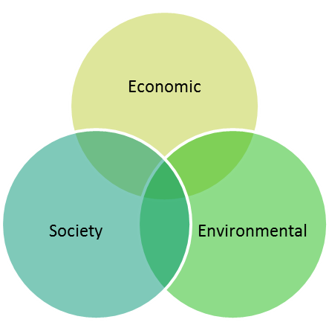

**Action Example: Hazard Disposal**

Goal: Minimize losses due to fire

Objective: Increase score in “Outside Fuel and Ignition Hazards”

Timeline: Short-term

Action: Summer Village has an annual hazard disposal program

Evaluation of Action:

* Economic: potentially economically effective if majority of community participates
* Environmental: cleaning hazards has a positive environmental impact

Figure . Sustainability Venn diagram

* Society: Gives the community social opportunities and develops community pride

Benefits:

* Possible opportunity to educate residents on fire safety and general knowledge
* Simple way to start reducing hazards on, and surrounding properties
* A suggested best practice in the Accreditation Audit Form

## Implementing Actions

Once actions have been agreed upon the Summer Village must decide how to implement them. When determining the details of implementation, keep the following questions in mind:

* What resource are necessary to implement the action (money, time, labour, etc.)?
* Who is responsible for specific tasks?
* When is the action going to be completed?
* Other questions to consider when implementing actions?

**Implementation Example: Hazard Disposal**

Resources needed:

* Personnel: Volunteers, contractor
* Equipment: Work gloves, safety glasses
* Other: Food and water
* Financial: approximately $0000.00

Person(s) responsible for task:

1. John Doe
2. Jane Doe

Action completion date:

* Advertising completed by April 30
* Contractors booked by May 31
* Event completed June 15

Other Considerations:

* If event is successful, initiate planning for next year.

**Action:**

Goal:

Objective:

Timeline:

Action:

Evaluation of Action:

* Economic:
* Environmental:
* Society:

Benefits:



**Implementing Action:**

Resources needed:

* Financial:
* Personnel:
* Equipment:
* Other:

Person(s) responsible for task:

Action completion date:

Other Considerations:

# Monitoring and Evaluation

Monitoring and evaluation are the last steps in the Fire Protection Plan, prior to the cycle starting again. Monitoring means to systematically review the progress of the actions over time. Evaluation means to assess if the actions are meeting the objectives; is the Accreditation Audit Form score increasing?

## Monitoring

Monitoring determines if actions are being implemented in a timely manner, within budget and are effective. If actions are not being implemented in an appropriate manner a Fire Protection Plan may be at risk of not meeting the goals and objectives.

|  |  |  |  |
| --- | --- | --- | --- |
| **Monitoring Sheet**  **Are Actions being Implemented (Y or N)** | | | |
| **Action** | 2016 | 2017 | 2018 |
|  |  |  |  |
|  |  |  |  |
|  |  |  |  |
|  |  |  |  |
|  |  |  |  |
|  |  |  |  |

**Explanation of why actions are not being met**:

## Evaluation

Evaluation determines if the actions are working towards achieving the objective. If the objectives are achieved, the goal will also be achieved.

|  |  |  |  |
| --- | --- | --- | --- |
| **Evaluation Sheet**  **Are objectives being met (Y or N)** | | | |
| **Objective** | 2019 | 2022 | 2025 |
|  |  |  |  |
|  |  |  |  |
|  |  |  |  |
|  |  |  |  |
|  |  |  |  |
|  |  |  |  |

**Explanation of why objectives are not being met**:

# Summary of Fire Protection Process

|  |  |  |  |  |  |
| --- | --- | --- | --- | --- | --- |
| Goal | Objective | Action | Implementation | Monitoring | Evaluation |
| To minimize losses due to fire | Increase score in “outside fuel and ignition hazards” | Develop a hazard reduction program | Implement the hazard reduction program | Has the hazard reduction program been implemented | Over time assess if scores are increasing |
| Increase score in “Structures” | Develop an incentive program to test existing and install new smoke detectors in every residence | Implement the program | Assess how many Rate Payers participated in the program and had existing smoke detectors tested or installed new smoke detectors |
| Develop an incentive program to inspect existing fire extinguishers and install fire extinguishers where needed | Implement the program | Assess how many Rate Payers participated in the program and had fire extinguishers inspected and/or installed in their residence and out buildings |
| Develop an annual training program where rate payers are trained and practice using fire extinguishers | Annual delivery of the program | Document Rate Payer participation in the program |